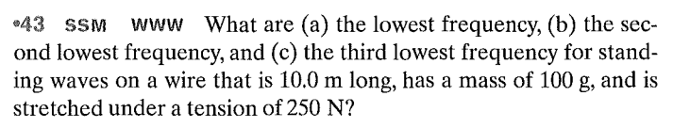

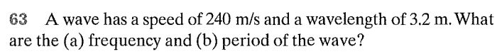

**Questions:**

